State of New Mexico OSAP

State Level
2017 Annual SFS Results– Middle School

(NOT YET COMPLETE)

Youth-Targeted Goal and Objectives:

Goal 1: Reduce underage drinking in New Mexico.
Objective 1: Reduce social access to alcohol by minors by…(increasing perception of risk of being caught; increased law enforcement efforts,
Objective 2: Reduce retail access to alcohol by minors by… (increasing perception of risk of being caught; increasing SID checks of retailers and increasing retail education, server training, etc.)

Goal 2: Reduce binge drinking among underage youth in New Mexico.

Goal 3: Reduce drinking and driving among underage youth in New Mexico.

Goal 4: Reduce prescription pain killer misuse and abuse among youth 12 to 25 in NM.

Program Setting (includes community and school description):

Brief Sample Description (include how sample was selected and data were collected):

Table 1a describes the overall sample and the sample broken down by gender. Table 1b provides students’ understanding of their parent’s educational level. Many youth do not know this information.

Table 1a: Demographics for participants by gender
Variable | Overall | Boys | Girls
Number of participants | 3,254 | 1,569 | 1,638
Age
Mean | 12.8 | 12.9 | 12.7
Range | 10-16 | 10-16 | 10-16
 | n | % | %
10 | 1 | 0.1 | 0.0
11 | 326 | 9.8 | 10.3
12 | 917 | 26.1 | 30.7
13 | 1175 | 36.7 | 36.4
14 | 721 | 24.2 | 20.4
15 | 80 | 2.9 | 2.1
16 or over | 7 | 0.4 | 0.1
Grade
5th grade | 5 | 0.2 | 0.1
6th grade | 806 | 24.6 | 25.7
7th grade | 1207 | 37.1 | 37.9
8th grade | 1191 | 37.9 | 36.2
9th grade | 5 | 0.2 | 0.1
Race/Ethnicity
White | 827 | 26.5 | 24.5
Hispanic | 2013 | 60.7 | 63.9
Native American | 171 | 5.6 | 5.0
Other | 243 | 7.1 | 6.6
Language Other than English Spoken Often at Home
Yes | 1131 | 34.0 | 36.5
Number of Spanish Surveys | 17

Table 1b: Parental education level
Parents education level | %
Parents education level | Mother (n=3195) | Father (n=3202)
Not sure | 36.8 | 41.9
Some high school or less | 8.4 | 9.7
High school or Some college | 29.6 | 29.2
College and above | 25.3 | 19.2
Table 2 captures the percentage of participants self-reporting any past 30-day and lifetime substance use overall and by biological sex

Table 2: Past 30-day and lifetime ATOD useª overall and by sex
 | Total valid | Overall |  |  | Total valid |  | Boys |  |  | Total valid |  | Girls
Substance | N | n^{b} | % | N |  | n^{b} |  | % | N |  | n^{b} |  | %
Past 30-day use
Cigarettes | 3203 | 132 | 4.1 | 1553 |  | 68 |  | 4.4 | 1623 |  | 63 |  | 3.9
Chewing Tobacco | 3199 | 132 | 4.1 | 1553 |  | 96 |  | 6.2 | 1619 |  | 34 |  | 2.1
Alcohol | 3199 | 312 | 9.8 | 1551 |  | 131 |  | 8.4 | 1622 |  | 175 |  | 10.8
Binge Drinking | 2944 | 160 | 5.4 | 1407 |  | 68 |  | 4.8 | 1515 |  | 90 |  | 5.9
Marijuana | 3193 | 288 | 9.0 | 1547 |  | 141 |  | 9.1 | 1620 |  | 143 |  | 8.8
Un-prescribed Rx Stimulant Use | 3183 | 109 | 3.4 | 1546 |  | 46 |  | 3.0 | 1611 |  | 62 |  | 3.8
Rx Painkiller Use to Get High | 3179 | 88 | 2.8 | 1538 |  | 39 |  | 2.5 | 1615 |  | 47 |  | 2.9
Lifetime use
Alcohol | 3190 | 833 | 26.1 | 1544 |  | 422 |  | 27.3 | 1620 |  | 400 |  | 24.7
Marijuana | 3186 | 468 | 14.7 | 1545 |  | 228 |  | 14.8 | 1615 |  | 234 |  | 14.5
Inhalant | 3154 | 252 | 8.0 | 1522 |  | 98 |  | 6.4 | 1607 |  | 151 |  | 9.4
ª Dichotomous substance use variable (yes or no).
^{b} n= number of positive responses

For some substance use questions, participants could select from several responses the number of days or times a substance was used by the individual in the past month, from zero days to 30 days, or 0 times to 40 or more times. Table 3 reports the most frequently selected category for days/times-of-use of each substance along with the actual percent that reported among current ATOD users. The frequency of use most reported by participants is indicated in the second column and the actual correspondent percent is reported in the third column.

Table 3: Most frequently selected (mode) days-of-use category or times-of-use category of past 30-day ATOD use among current users
Substance | Category with highest % | %
Number of Days-of-Use
Cigarettes (users n=132) | 1-2 days | 43.9
Chewing Tobacco (users n=132) | 1-2 days | 40.2
Alcohol (users n=312) | 1-2 days | 62.5
Binge Drinking (users n=160) | 1 day | 46.3
Number of Times-of-Use
Marijuana (users n=288) | 1-2 times | 41.3
Un-prescribed Rx Stimulant Use (users n=109) | 1-2 times | 52.3
Rx Painkiller Use to Get High (users n=88) | 1-2 times | 60.2
Note. If there are ties, then enter all tied categories.

The next three figures show how students accessed tobacco, alcohol, and prescription painkillers.

Figure 1. How tobacco was accessed in the last 30 days (n=413)
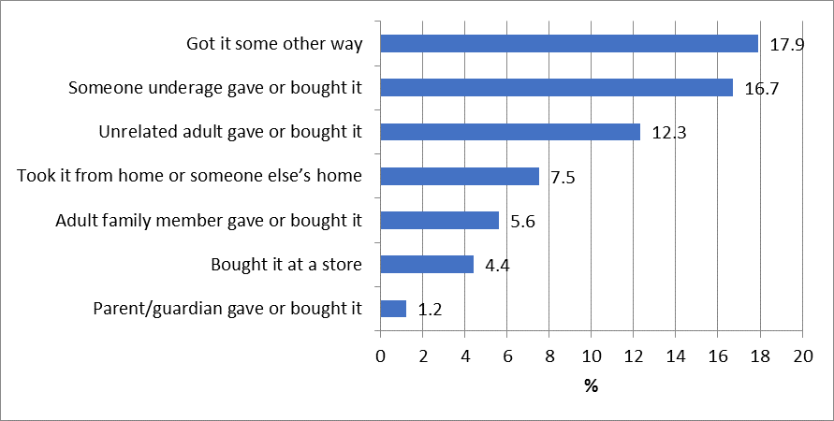
*The total respondents for this question differ from the number of respondents who reported smoking in the past 30 days because this question refers to all tobacco products including cigarettes, e-cigarettes, and chewing tobacco.

Figure 2. How alcohol was accessed in the past 30 days (n=366).
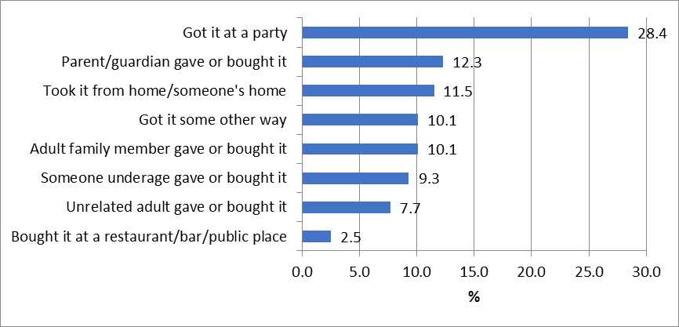
Note. The total respondents for this question differ from the number of respondents who reported current alcohol use because missing cases in the current alcohol use question are included in this question.

Figure 3. How prescription painkillers were accessed in the past 30 days (n=592).
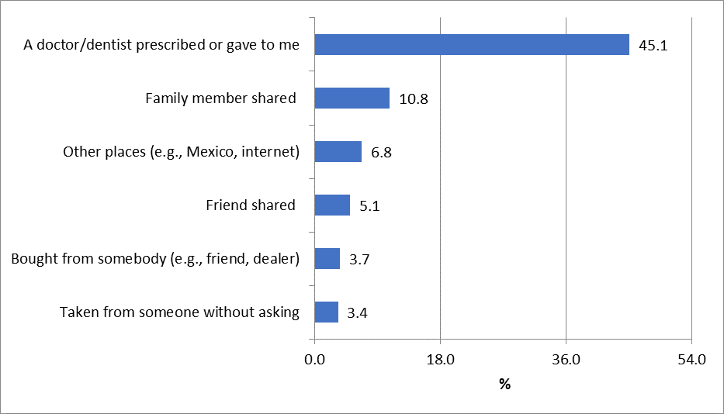
Note. The total respondents for this question differ from the number of respondents who reported used un-prescribed stimulant due to inconsistent wording across these questions therefore the number of this question is derived from the question “I didn’t use prescription pain killers in the last 30 days”.

Table 4 provides the percentage of participants who perceive that if they were drinking alcohol at school or in their community that it is likely or very likely they would get caught and face consequences from the school or police.

Table 4: Percent of participants reporting that it is very or somewhat likely that they will be caught and face consequences if drinking alcohol at school or in the community
Perception of risk of getting caught and facing consequences | % reporting likely or very likely
Perception of risk of getting caught and facing consequences | Overall | Boys | Girls
Likelihood of being caught by teachers or staff when drinking alcohol at school (n=3,128) | 75.1 | 73.5 | 76.7
Likelihood of getting into trouble with school if got caught drinking at school (n=3,114) | 89.2 | 88.1 | 90.3
Likelihood of being caught by police when drinking alcohol in the community (n=3,134) | 61.7 | 61.1 | 62.4
Likelihood of getting arrested or cited by police when drinking alcohol in the community (n=3,133) | 69.7 | 68.7 | 70.7

Table 5 shows the prevalence of participants who report using substances or being offered or sold drugs on school property during the past school year.

Table 5: Prevalence of substance use and availability of drugs on school property during the school year.
Substance (Total N =3,254) |  | %
Substance (Total N =3,254) | Overall | Boys | Girls
Use on Campus
Cigarettes | 1.5 | 2.1 | 1.0
Chewing Tobacco | 3.2 | 5.2 | 1.3
Alcohol | 3.1 | 3.0 | 3.1
Marijuana | 3.7 | 4.3 | 3.2
Prescription Drugs to Get High | 2.3 | 2.3 | 2.4
Offered or Sold on School Property
Illegal drugs | 12.2 | 12.6 | 11.8
Prescription Drugs | 6.3 | 6.2 | 6.5

Table 6a shows the prevalence of participants who perceive moderate or great risk of harm associated with ATOD use.

Table 6a. Perceived risk of harm associated with ATOD use
Risk of harm (Total N =3,254) | Moderate or great risk (%)
Smoke one or more packs of cigarettes per day | 86.6
Use e-cigarette on a daily basis | 58.2
Smoke marijuana once a month or more | 59.4
Smoke marijuana once or twice a week | 69.3
Have one or two alcoholic drinks nearly every day | 70.1
Have five or more alcoholic drinks once or twice a week | 77.0
Use Rx painkillers for non-medical reason | 85.6

Table 6b provides the percent of participants who agree that their parents would feel that it was wrong or very wrong for participants to drink alcohol regularly and the percent of participants who agree that it is wrong or very wrong for participants their age to drink alcohol regularly. The table also includes the percent of participants who indicate that they intend to smoke.

Table 6b: Parents and youth attitudes towards ATOD use and youth’s intentions to smoke.
Attitudes Toward ATOD use | % Feeling wrong or very wrong
Parents feel wrong for me to drink alcohol regularly (n=3,212) | 91.5
It is wrong for someone my age drink alcohol regularly (n=3,216) | 86.8
Intentions to Smoke (limit to participants who were not smoker) | % of Yes
Try smoking a cigarette soon (n= 2,929) | 2.9
Smoke a cigarette at any time during the next year (n=3,186) | 6.0
Smoke if one of your best friends offered a cigarette (n=3,184) | 7.0

Figures 4 & 5 show the percentage of youth who reported recognizing real and fictitious media campaigns to address youth ATOD use. Two of these campaigns are real. These are: “Parents Who Host Lose the Most” and “A Dose of Reality.” If prevention programs are promoting one or both of these campaigns, the percentages should increase over time. If prevention messages for “A Dose of Reality” are being correctly interpreted then, increased exposure should lead to greater understanding of the prevention. Please note that Figure 5 only includes students who select one interpretation of “A Dose of Reality”.

Figure 4. Reported percentage of media campaigns recognized by participants (n=3,254)
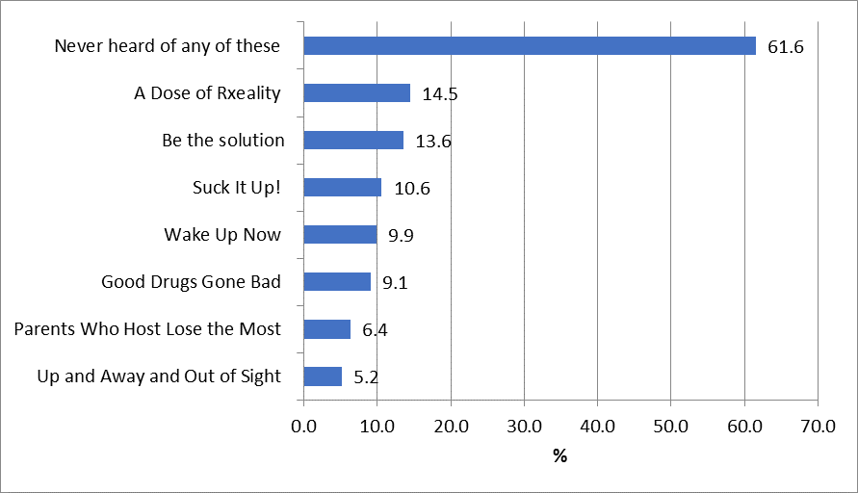

Figure 5. Reported percentage of media campaign messages interpreted by participants
(Note that this only includes students who select one interpretation of “A Dose of Reality”) (n=2,966)
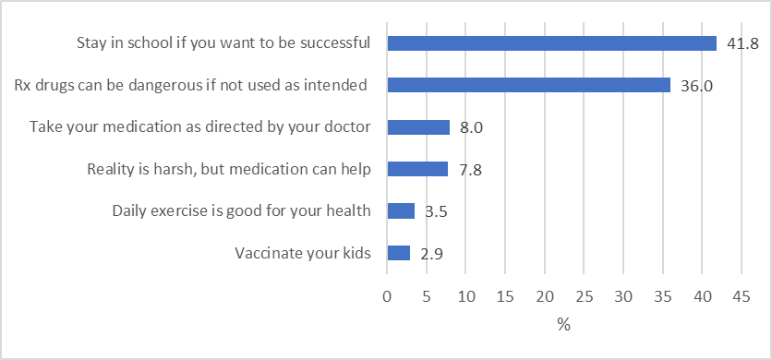
Discussion of Findings of Annual SFS for Middle School

Consider the following statements & questions as prompts only. You may remove these and summarize the information & findings you feel are most important to communicate to OSAP.

- Note any observed trends or changes in demographics that might affect your results. (e.g., predominantly female, predominantly younger, one SES etc.) (Table 1a) Is this a representative sample of students in your community? Why or why not? How might it influence your results?

- Reflect on the prevalence of ATOD use in your sample. (Tables 2 & 3) Does the prevalence seem high, low, or about right? Why? How does it compare with similar estimates from the YRRS? If your estimates are very different from the YRRS, why might that be? How is the perception if risk of getting caught by law enforcement and facing legal consequences (Table 4) associated do you think? (You can run a correlation between the measures to see for sure.) What about the perceived risk of harm (Table 6a)? Do students perceive a low risk of harm and greater use or do they report a high risk of harm and still use? Similarly, attitudes reported on in Table 6b may be associated.

Lifetime prevalence of alcohol and marijuana increase slightly in FY17 compared with FY16, but only slight. Both are down since FY15; almost two percentage points for lifetime marijuana use and six percentage points for lifetime alcohol use.

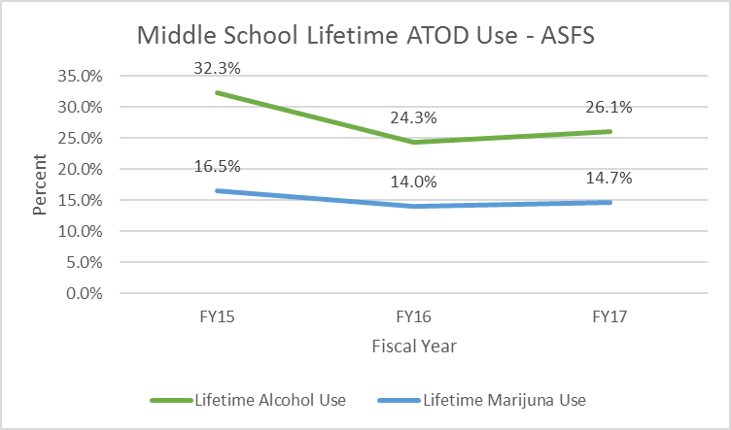

With respect to current ATOD use among middle school students, we see continued decreases in cigarette and alcohol use over the past three years. Since FY15, current cigarette use decreased from 5.9% to 4.1% in FY17. Current alcohol use decreased from 15.5% in FY15 to 9.8% in FY17. Binge drinking also decreased from 8.0% in FY15 to 5.4% in FY17. Current marijuana use remains troublingly high, although it has decreased since FY15 as well. Current prescription pain killer use to get high has only been measures for the past two years and increased slightly this year from 2.3% in FY16 to 2.8% in FY17, making prescription pain killers the least frequently used substance measured.

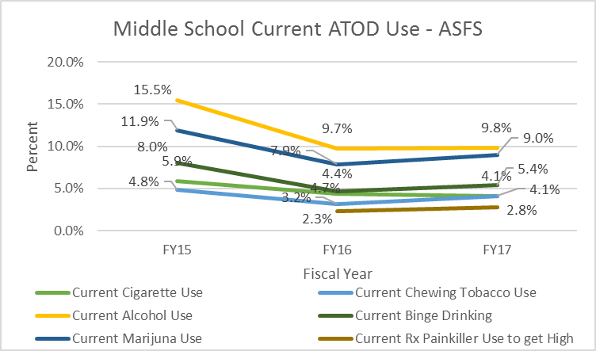

- Describe substance use and availability on school campus during the school year (Table 5) and how it relates to the perceived risk of being caught and getting in trouble (Table 4). Are they related? Can there be improvement? What might be done to address the use and/or the perception of risk associated with it?

- Describe participants’ access to alcohol on Figures 1 and how your prevention efforts are addressing social access to alcohol. What is the most common way that minors access Rx drugs according to Figure 3?

- What implications can be drawn about the prevention efforts taking place based on these results? Are there areas where you can see room for improvement? How might you address them as a coalition? Do some IVs stand out as more critical than others for prioritization?

- Are there additional results & issues that are not represented in the tables that should be mentioned and brought to the attention of OSAP?

